
Information Technology Division

Medicaid Enterprise Systems
Data Management Strategy

Version 0.01
Dec 08, 2021

Version Summary
Version | Date | Version Summary | Prepared by
0.01 | 12/08/2021 | Draft | Sadiq Hasan, Jerry Nicholson, Michael Kagori

Table of Contents
Introduction 3
In Scope for NC MES 4
NC MIMS DMS Audience 4
NC MIMS Data Management Strategy (DMS) 5
1) Data Governance 5
Data Governance Overview 5
NC MES Data Governance Mission 6
NC MES Data Governance Goals 6
2) Data Stewardship 8
3) Common Data Architecture 9
4) Data Modeling 10
6 Data Sharing Architecture 12
7. Data Standards 20
• CAQH 20
• NIEM 20
• NMEH 20
• HL7 RIM 20
• HIPAA 21
• T-MSIS 21
Key Considerations of the MITA Data Management Strategy 21
Data Standards (Received from v1.0 and need to be reviewed) 22
Development Standards and Maintenance Organizations 28
Data Standards Management Organizations (DSMO) 30

To be removed: The DMS defines an enterprise-wide data strategy that addresses the business flow of data across the Medicaid Enterprise. It involves architecture, modeling, standards, metadata, management, interoperability, Security & Privacy (S&P), access methods, quality, and performance standards.
H:\CMS Documents\MITA 3.0\MITA Part-ii\Part II\PDF Files\Part II Chapter 2 Data Management Strategy 3.0.pdf

(Components of the DMS)
- Data Governance  - Common Data Architecture  - Data Modeling  - Data Standards  - Metadata Management  - Interoperability  - Security & Privacy  - Access Methods  - Data Quality  - Performance Standards | - Enterprise Data Management and Data Stewardship – (Data Governance  - Common Data Architecture –  - Enterprise Modeling  - Enterprise Metadata Repository  - Data-Sharing Architecture (Data Standards, Security & Privacy, Interoperability, Access Method, Data Quality)

Introduction

This North Carolina (NC) Medicaid Enterprise System (MES) Data Management Strategy (DMS) document was developed to provide governance for the NC Medicaid Interoperable Modula System (MIMS), and to support efforts to implement an Information Architecture that sets standards across NC’s Medicaid Enterprise System (MES). The primary purpose for the DMS is to document the data management processes, techniques, and products needed by the Medicaid Enterprise to achieve optimal sharing of Medicaid Enterprise Information
NC DMS is also designed to facilitate the Center for Medicare and Medicaid Services (CMS) MITA goals - to provides seamless interoperability across the Medicaid Enterprise as State Medicaid Enterprises need to exchange and share information internally, and with other state and federal agencies, organizations, and enterprises.

In Scope for NC MES

- The scope of information for NC MIMS include data used by its Medicaid business processes and programs as will be shown in the Information Architecture Conceptual and Logical Data Models. This information is derived from modules that support MITA’s ten Business Areas.

- In addition to MITA’s ten Business Areas, the state of North Carolina is collaborating with CMS to embark on a state specific Data Warehousing initiative to provide Business Intelligence, Predictive Analytics, Decision Support, and Reporting service in a cloud based Data Management System (DMS) repository. This initiative is defined in a new state proposed business area called - Decision Support Management (DMS). The DSM will receive transactional data in “real time” or “near real time” from the 10 MITA 3.0 Business Areas presented in Figure 1 below.

- Any data ingested into the DSM from other state agencies, and 3rd party contractors will adhere to the standards outlined in our data management strategy with no exception
Figure 1: NC DSM receives data from MITA 10 Business Areas

NC MIMS DMS Audience

The NC MIMS Data Management Strategy is intended for use by the Data Stewards (Business Analysts, Data Architects, Data Analysts, Data Modelers, Developers, and Database Administrators) responsible for defining and delivering the Information Architecture, and Technical Architecture. The Data Stewarts are primarily responsible for implement the policies, techniques, and processes to achieve effective sharing of information across internal and external boundaries and advance towards the goal of achieving modularity and interoperability. The techniques and processes include data analysis, data modeling, normalization, Entity Relationship Diagrams, Star Schemas, Snowflake Diagrams, metadata management, and adherence to industry standards best practices for bringing data under control.

NC MIMS Data Management Strategy (DMS)

CMS states that - the DMS provides mechanisms to monitor and influence the environment in which Medicaid operates with respect to both the data landscape and the enabling technologies. Data landscape refers to the broad range of national initiatives, standards organizations, and other organizations engaged in defining or influencing standards such as the Council for Affordable Quality Healthcare (CAQH) and the National Medicaid EDI Healthcare (NMEH) workgroups. Enabling technologies refer to open standards, protocols, middleware, and other mature or emerging technologies that facilitate data sharing.
NC DMS addresses the business flow of data across the MES by focusing on the following key areas:

- Data Governance – According to CMS – “A Data Administration Team to maintain the architecture of Medicaid Enterprise Data from a conceptual and logical view is recommended, to report up to the MITA Executive Governance Committees”.

To satisfy this request NC MES is currently creating a Data Governance charter as a pre cursor to establishing a Data Governance Committee (DGC). The DGC’s primary role will be to set the policies and standards for bringing data under control and keeping it secure. It requires knowing where data is located, how it originated, who has access to it, and what it contains. It is a prerequisite to maintaining business compliance regardless of if that compliance is self-imposed or required by industry or government mandates. The establishment of our Data Governance Committee will set the policies, procedures, and provide oversite to ensure that all parties comply with our data management strategy.

Data Governance Overview

Data governance programs generally includes several organizational bodies. Data governance involves Data owners, data stewards, data stakeholders, and an executive board to support an organization framework.
At a high level, North Carolina (NC) state’s data/reporting environment is characterized by a data governance framework, which informs governing bodies, who are responsible for creating standards and for guiding/prioritizing largescale data/reporting initiatives and projects, for data that is managed and consumed by various agencies and stakeholders. The following diagram is a graphical representation of the data governance committee.
Figure 1: Environmental Overview
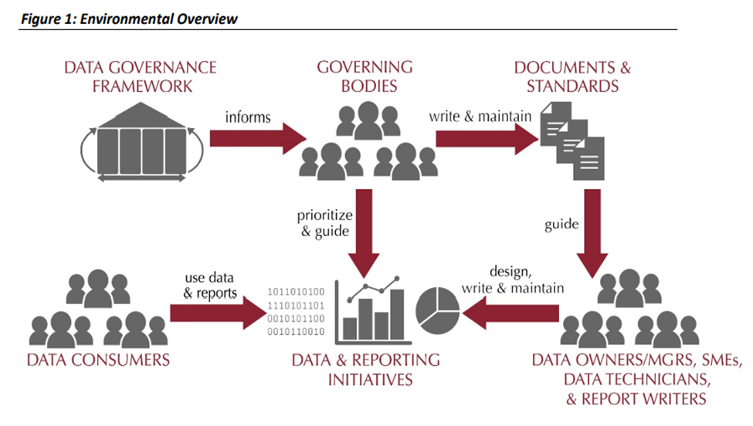

NC MES Data Governance Mission
North Carolina (NC) state’s data governance program is intended to create the best possible environment to support NC MES data-driven decision-making. It will set policies and procedures to facilitate a better understanding of where data is located, how it originated, who has access to it, and what it contains; it is a prerequisite to maintaining business compliance.
The program keeps an enterprise perspective but also allows for local/departmental flexibility. Lastly, the program is considered an ongoing NC MES wide effort that requires monitoring and maintenance to support continuous improvement; it is not a one-time information technology initiative.

NC MES Data Governance Goals
To achieve the NC MES data governance mission, we have established the following goals:
Create standardized architecture and integration
Ensuring that we have common data definitions and that those definitions are made available across MES platforms is essential to enabling data-driven decision-making. The Program also supports decisions on data definitions and on the technical support required to manage, integrate, and disseminate those definitions.
Support Security and Compliance
The Program will develop risk management strategies and will support standards for compliance with privacy, security, and record retention policies for different record types. It will ensure that NC MES data is following federal and state policies.
Facilitate Information Quality
The program outlines responsibilities of data owners and data managers for ensuring data integrity, data quality, and fitness for use. The program also supports the notion that data consumers bear responsibility for providing input to data owners and data managers to support continuous service/data improvement. The data used will be rationalized into information value chains that are treated in accordance with legal, regulatory, contractual and MES/ DHHS standards
Support People and Technology
The program will ensure sufficient human and technological resources to support the initiatives, projects, and environments that support data-driven decision-making. All data in the MES ecosystem can be utilized across all service offerings and business models subject to usage and access restrictions. Information value chains will be leveraged to maximize value across several patterns to enhance services.
Create Policies and Standards
The program will create structured accountability by defining roles and responsibilities, and by establishing decision rights relative to the recommendation and creation of policies, priorities, processes, and standards. The program should also facilitate collaboration and education related to policies and standards.
Support Change Management Standards
Consistency and stability of the environment is a cornerstone to the success of the program. Best-practices change management processes will be created to ensure this consistency and stability.
Support Information Literacy and data-driven decision making
To enable departments to engage in data-driven decision-making, we must establish a culture of information literacy. Information literacy will be supported by the four pillars of data governance:
  - Policies and Standards
  - Compliance and Security
  - Information Quality
  - Architecture and Integration
Integrity
Data governance participants will practice integrity with their dealings with each other; they will be truthful and forthcoming when discussing drivers, constraints, options, and impacts for data- related decisions.
Transparency
Data governance and stewardship processes will exhibit transparency; it should be clear to all participants and auditors how and when data- related decisions and controls were introduced into the processes.
Auditability
Data related decisions, processes and controls, subject to data governance, will be auditable; documentation will accompany them to support compliance-based and operational auditing requirements.
Accountability
Data governance will define accountabilities for cross-functional data-related decisions, processes and controls.
Policies
The Data Governance Council (or similar body) conducts the final review, revision and adoption. Policies may take different shapes, as in the following examples:
- The Data Governance Office (DGO) will certify data for use by the organization.
- Business owners will be approved by the Data Governance Office.
- Business owners will designate data stewards from their business capability areas.
- The data stewards will have day-to-day responsibility for coordinating data governance activities. Whenever possible, standardized reporting and/or dashboards/scorecards will be made available to serve most business needs.
- Certified users will be granted access to certified data for ad-hoc/non-standard reporting.
- All certified data will be evaluated on a regular basis to assess its accuracy, completeness, consistency, accessibility, uniqueness, compliance and efficiency.

- Data Stewardship – Refers to the individuals or teams responsible for implementing the DMS; they include Business Analysts, Data Analysts, Data Modelers, Database Administrators, and Developers. The data stewards primary role is to apply our DMS policies and procedures to data ingested and exchanged across the MIMS.
Data Steward is responsible for the governance of data (including transfer, alteration, storage, retention, disposition, classification, etc.). This includes documenting limitations and bias within data. Support established processes and policies for access and use, including metadata, which is essential for strategic use. Collaborate with Data Owner to ensure strategic use. Collaborate with Data Custodian to ensure data availability. When applicable, responsible for cell suppression methodology and other statistical, data-based safeguards. Often the subject matter expert that works with data regularly for business purposes. Role: Analyst, Epidemiologist.
Data stewardship: Data stewardship includes the processes involved with acquiring, storing, using data, as well as the data’s security and quality. While data stewardship is the overarching principle, data governance includes the processes of how these principles are carried out.

Define Stewardship and Maintenance Processes
Technical solutions can do remarkable work matching, merging, and managing identifiers for master records. However, the process also requires stewardship, not only to address records that fall out of the process, but also to remediate and improve the processes that cause them to fall out in the first place. MDM projects should account for resources required to support the ongoing quality of Master Data. There is a need to analyze records, provide feedback to source systems, and provide input that can be used to tune and improve the algorithms that drive the MDM solution.
- Common Data Architecture

Common Data Architecture is the term used to describe the establishment of standard data management procedures for the data models and guidelines for data documentation, data-sharing development and use applicable to both structured and unstructured data, and management of metadata of all types. These guidelines ensure that all parties to system design/redesign efforts utilize pre-defined data entities and attributes, data models, and relationships to convey the overall meaning and use of Medicaid data and information. The Seven Standards and Conditions, State Self-Assessment (SS-A), MITA Maturity Models (MMM), Concept of Operations (ConOps) (COO), and Business Process Models (BPM) provide a foundation for common data architecture. The goals of common data architecture include:
Defined data to support the business “To-Be” goals.
- Improved consistency in the development and deployment of systems.
- Increased the data quality and performance of systems.
- Normalization of data across applications.
- Decreased complexity of the Extract, Transform, and Load (ETL) process.
- Decreased resource expenditures involved in new or redesigned system efforts.
- Identification, documentation, and limitation of the number of source data locations and access points.
- Redundant data by improving communication about available classes and attributes, as well as assigning owners to promote modeling responsibility.

Information Architecture
The Information Architecture for the State’s Medicaid Enterprise System (MES) provides a conceptual and logical view of the data commonly used in Medicaid Enterprise, descriptions of the information, architecture, Governance, Data Standards, Quality and Security. The key aspects of the conceptual (and successive) data models will be determined during the design and implementation of the Medicaid Enterprise System. The domain areas/sub-groupings used to describe the Information Architecture are those facilitated by the Conceptual Data Model (CDM) and Logical Data Model (LDM). These sub-groupings allow either a portion of the model to be viewable or the entire model to be viewable at an overview level. The architecture is the primary tool for strategic planning, communicating information requirements throughout the organization, implementing integrated systems, and providing an integrated information strategy.
The State uses the LDM to build Logical Application data models including state-specific adaptations and extensions to provide application-specific details. Architects and designers build application data models at both the logical and physical abstraction levels and reuse data objects defined at the enterprise level. This ensures that application models have common keys, attributes, and definitions throughout the enterprise data architecture. A single entity in the data model exists in multiple application-specific models with attribute and code set variations based on business need (i.e., rules) or as subtypes of more generic enterprise entities. A single entity in the MITA data model supports data consistency and reuse.
The Information Architecture provides the guidance on selecting a data management strategy that meets national standards for data sharing and interoperability. It also enables the State to use common strategies (e.g. data marts, ODS) when designing Medicaid information solutions. All states, CMS, vendors, legislators, and others will use the architecture’s components to plan for improvements in the State Medicaid Enterprise, both in the delivery of services (i.e., to providers, beneficiaries, and citizens) and in its internal operations and exchanges of information with other external parties.

- Data Modeling – NC MES have embracing Data Modeling for all data ingested and exchanged between MIMS modules, state agencies, federal agencies, and 3rd party contractors. Data should not enter the MIMS eco system without going through Data Modeling and peer reviews prior to deploying the data in development, system test and production environments. In addition, vendors contracted to provide software solutions for the MIMS must submit a logical data model for review by the data stewards to ensure that their database design embrace the basic elements of Data Modeling for online transaction (OLTP) systems, and Online Analytical Systems (OLAP).

NC MES selected Erwin Data Modeler (a.k.a. Erwin) from Quest Software as their data modeling tool. Erwin can work in cloud and in data warehouse environments with structured, unstructured, and semi-structured data. It enables us to create Entity Relationship diagrams and apply techniques such as data normalization for OLTP systems, star schemas, and snowflake schemas for OLAP systems. Erwin also includes functionality to document, save, and export metadata (data about entities, attributes, and their relationships) to the database management system (i.e., Oracle, SQL Server, etc.) and to external metadata repositories.

Insert paragraph for Data Lakes, and NoSQL models
data lakes
Data warehouses began to be built in earnest in the 1990s. Since then (and especially with the co-evolution of Business Intelligence as a primary driver of business decision-making), data warehouses have become ‘mainstream’. Most enterprises have data warehouses and warehousing is the recognized core of enterprise data management. 63 Even though well established, the data warehouse continues to evolve. As new forms of data are created with increasing velocity, new concepts, such as data lakes, are emerging that will influence the future of the data warehouse.
To take advantage of Big Data, however, requires change in the way that data is managed. Most data warehouses are based on relational models. Big Data is not generally organized in a relational model. Most data warehousing depends on the concept of ETL (Extract, Transform, and Load). Big Data solutions, like data lakes, depend on the concept of ELT – loading and then transforming. As importantly, the speed and volume of data present challenges that require different approaches to critical aspects of data management, such as integration, Metadata Management, and Data Quality assessment.
While most assertions about Metadata for unstructured data are connected to traditional content management concerns, new practices are emerging around managing unstructured data in data lakes. Organizations wanting to take advantage of data lakes, using Big Data platforms such as Hadoop, are finding that they must catalog ingested data in order to enable later access. Most put in place processes to collect Metadata as part of data ingestion. A minimum set of Metadata attributes needs to be collected about each object ingested in the data lake (e.g., name, format, source, version, date received, etc.). This produces a catalog of data lake contents.

- - Metadata Management - Metadata is often described as data about data. To aid the understanding of NC DHHS MES Medicaid data, and the definitions and formats of that data an enterprise metadata repository is required to enable access by all stakeholders to view and utilize MES metadata. Good metadata management practice also allows for future systems to be designed and shared in a manner promoting data standards and interoperability.

To satisfy this requirement NC DHHS has acquired licensing for a data modeling and repository management tool from Quest Software – Erwin Data Modeler 2021. As part of the data modeling process Erwin Data Modeler provides capability to capture and store metadata on all entities and attributes. The metadata captured during the modeling process could be transferred to the Database Management System (i.e., Oracle, DB2, SQL Server, etc.) using the physical data model schema.

Metadata captured during the data modeling process will be saved along with the data model in the original Erwin file format. A second copy of the data model will be saved as a .pdf (i.e., Adobe PDF). Both copies will be stored on our designated SharePoint site, and they will be used primarily by the data stewards (Product Managers, Business Analysts, Data Analysts, Data Architects, Data Modelers, and Database Administrators) during day to day operations.

Data Models and Metadata will also be published in iServer from OrbusSoftware, along with other artifacts related to each MITA 3.0 Business Area. iServer is currently being purposed as our formal MES Metadata Repository for all artifacts related to MITA business areas.

Data Sharing Architecture
Data Sharing Architecture

Data-Sharing Architecture is the term used by CMS to describe the technology considerations for DCH program and technical staff (as well as vendor staff, as appropriate) to share enterprise information and standards for emerging data solutions (new or redesigned). Based on business requirements and MITA considerations, CMS recommends that Data Administration staff be responsible for the following aspects of data-sharing architecture: ν Defining and maintaining data and information exchange formats for future system efforts. ν Adopting MITA-standard data definitions and data-sharing schemas where possible. ν Maintaining a centralized meta-data repository7 of this information for general use. For CMS, data-sharing architecture (including the meta-data repository and associated modeling toolset) also addresses data semantics, data harmonization strategies, shared-data ownership, security and privacy implications of shared data, and the quality of shared data. It is a key technology to enable state solutions to promote sharing, leverage, and reuse of Medicaid technologies and systems within and among States, thereby reducing costs and achieving further levels of MITA maturity. The EDMS identifies enabling technologies and specifies data design structures to enable data interoperability, along with associated processes and procedures. The resulting IA leads to the development of the target or To-Be data management environment. New projects involving data architecture within DCH and where practical, changes to existing architectures, must adhere to the enterprise standards, which will be fully documented in the MITA Team’s Data Standards and Management Plan. This means that new systems will need to map the physical data source to the logical data model to ensure that data can be shared through well-defined interfaces. For domain standards, future systems must use the same coding standards and data sets to maintain context across enterprise systems. Enforcement of these standards is addressed in the discussion of roles within data management. Following the definitions defined by these vocabulary domain and datasets, groups will achieve this contextual integrity.

6.1 Standard Data Definitions
Data Standards
Data standards are necessary for data exchange between two or more parties. NC DHHS enforces to adopt industry standards. Industry standards promote reuse, data exchange, and reduction of administrative burden on patients, providers, and applicants. NC DHHS will update the data standards periodically to ensure conformance with changes in the industry. Data standards can be used for automated or manual processes.
The key elements of a data standard are:
- Data elements names
- Definitions
- Qualifiers
- Data types
- Relationships
- Semantics
- Contextual rules

6.2 Standard Data Sharing Schemas
Data Standards, Data Schemas and Data Dictionary
NCMES will have a centrally defined data standards and data schemas to share the data. For Provider detail business process data sharing, provider detail data schema will be defined, and data security will be enforced on the field level. Also the data dictionary will be provided along with valid values.

6.3 Centralized Dictionary and Centralized Directory
6.4 Data Hub
ENTERPRISE DATA HUB ARCHITECTURE
NC MES Enterprise Data Hub Architecture describes the technology considerations for the business requirements to have a large storage repository that house a vast amount of raw data (Structured or unstructured). The data is stored in its native format until it is accessed for enterprise-wide information storage and sharing.
The Data Hub architecture capabilities include handling of unstructured and differently structured data and substantial gains in scalability and elasticity. The capabilities to process and store exceptionally large volumes of data and to ingest data at high speed proved valuable for advanced analytics and data science efforts.
The NC MES Data hub includes features for data storage, homogenization, harmonization, indexing, processing, governance, metadata, search, and exploration for the data received from all the NC MES Data Sources and external data sources. The below diagram represents the conceptual view of the NC MES Data Hub Architecture.
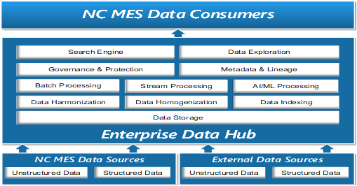
Figure 5 – Conceptual View of Data Hub Architecture
The enterprise data hub strategy helps the department make better use of the available data and leverage the right data across Medicaid Application systems. The main benefits of NC MES Data Hub strategy include
- All content from NC MES Stake holders will be ingested into the data hub and make available for search, providing a 360º view of Medicaid enterprise data.
- The hub eliminates complex SQL query execution; content can be served to users via search.
- The enterprise data content prepared by metadata extraction, format conversion, augmentation, entity extraction, cross-linking, aggregation, de-normalization, and indexing.
- The data users and or the application systems within enterprise will have secure access to the data hub's content depending on the business needs. This helps drive optimized business decision and increases the consumption of data.
- The data hub strategy enables state staff and other stakeholders, to obtain insights and solve challenges.

6.5 Repository
Enterprise Metadata Repository
To aid the understanding of enterprise data held in systems and the definitions and formats of that data (the “metadata”), an enterprise metadata repository is required to enable access by all stakeholders to enterprise metadata. This allows for future systems to be designed and shared in a manner promoting
data standards and interoperability. Future systems designed with reusable enterprise data structures and metadata will be more easily shared.

CMS states that the benefits to using an enterprise metadata repository include increased ability to obtain data at the right time, increased data quality, and decreased resources required to maintain data. State
solutions should promote sharing, leverage, and reuse of Medicaid artifacts, technologies, and systems within and among States. Note that CMS itself plans to release more information as repositories and registries are established at the federal level.
For GA DCH, the metadata repository is currently within the Erwin tool.

6.6 Registry (i.e HIX and HIE,)
Health Information Exchange (HIE)
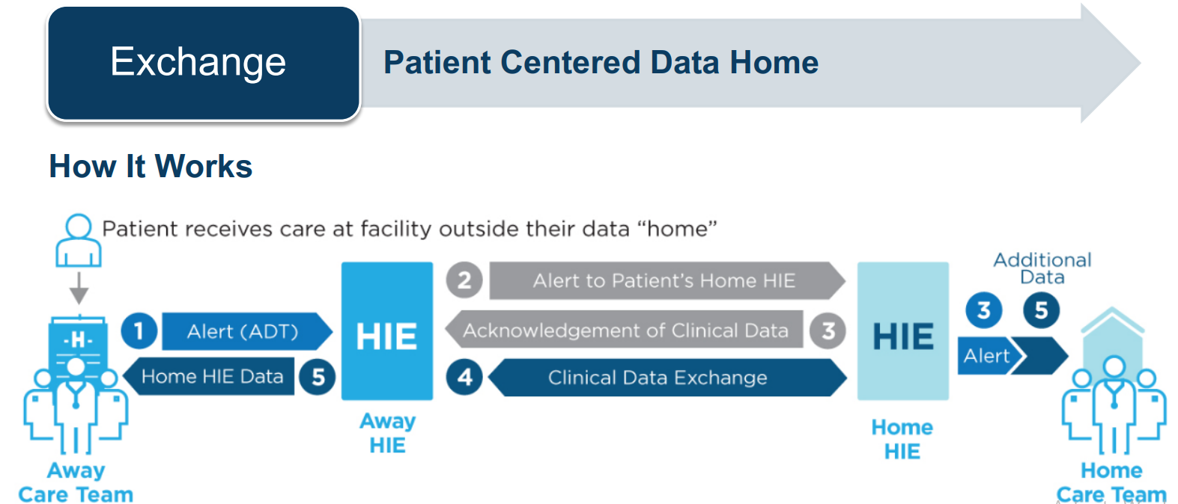

6.9 Data Semantic

6.10 Data Harmonization
Data Harmonization Strategy
Data Harmonization enhances the quality of business data. Data Harmonization significantly improves the performance of the creation and access of Business Intelligence insights.
Following steps will be implemented for NCMES Data harmonization process:
- Identify the relevant sources
- To collect data
- Clean and harmonize
- Identify incorrect, inaccurate or inconsistent parts of the data and modify
- Quality check
- To maintain acceptable level of integrity and validity
- Convert to a common format

6.11 Interoperability
Data Integration & Interoperability

Data integration and interoperability includes the acquisition, extraction, transformation, movement, delivery, replication, federation, virtualization, and operational support of data.

Robust integration and interoperability capabilities help the State avoid costly customizations by providing the future state with the ability to use modern tools and reusable patterns and standards that are more loosely coupled, secure, and easier to maintain. The core elements of data integration and interoperability can include:

  - Approaches to include deep integration (predominantly tight coupling, used only when necessary) or to interoperate (loose coupling, the preferred implementation method)
  - Standards (e.g., Representational State Transfer (REST), Simple Object Access protocol (SOAP))
  - Architecture patterns (e.g., Service Oriented architecture (SOA), Data Services)
  - Acquisition of data including integrating third-party data
  - Movement of data including data integration, transformation, virtualization, migration and conversion, and messaging
  - Operational standards including allowable patterns and methods for access, security, lineage, sharing agreements, quality and recombination, and exception handling
  - Extract, transform, and load (ETL) strategies, tools, methodologies for data migration and integration

The architecture vision for the future state, as it pertains to integration and interoperability, is far different from the current state scenario of tightly coupled, point-to-point integrations. The target- state is envisioned to be consistent with a modern approach, aligning where feasibly possible, with the strategic direction of emerging industry trends. This approach addresses the lack of real-time or near real-time interface capabilities.

Data Integration and Interoperability (DII) describes processes related to the movement and consolidation of data within and between data stores, applications and organizations. Integration consolidates data into consistent forms, either physical or virtual. Data Interoperability is the ability for multiple systems to communicate. DII solutions enable basic data management functions on which most organizations depend:
- Data migration and conversion
- Data consolidation into hubs or marts
- Integration of vendor packages into an organization’s
- application portfolio
- Data sharing between applications and across organizations
- Distributing data across data stores and data centers
- Archiving data
- Managing data interfaces
- Obtaining and ingesting external data
- Integrating structured and unstructured data
- Providing operational intelligence and management decision support.

DII is dependent on these other areas of data management:

- Data Governance: For governing the transformation rules and message structures

- Data Architecture: For designing solutions

- Data Security: For ensuring solutions appropriately protect the security of data, whether it is persistent, virtual, or in motion between applications and organizations

- Metadata: For tracking the technical inventory of data (persistent, virtual, and in motion), the business meaning of the data, the business rules for transforming the data, and the
- operational history and lineage of the data

- Data Storage and Operations: For managing the physical instantiation of the solutions.

- Data Modeling and Design: For designing the data structures including physical persistence in databases, virtual data structures, and messages passing information between applications and organizations.

Data Integration and Interoperability is critical to Data Warehousing and Business Intelligence, as well as Reference Data and Master Data Management, because all of these focus on transforming and integrating data from source systems to consolidated data hubs and from hubs to the target systems where it can be delivered to data consumers, both system and human.

Data Integration and Interoperability is central to the emerging area of Big Data management. Big Data seeks to integrate various types of data, including data structured and stored in databases, unstructured text data in documents or files, other types of unstructured data such as audio, video, and streaming data. This integrated data can be mined, used to develop predictive models, and deployed in operational intelligence activities.

6.12 Security & Privacy
Data Security
Data security confirms the privacy, confidentiality, and appropriate access of data. This includes how data is secured at rest, in use, and in motion.
A modern and robust data security architecture is necessary to satisfy all Federal and State and Department law, rule, and statutory requirements that protect the legal rights of the people and institutions whose data is used in the future state solution. There are many critical areas included in data security to consider:
- Security Requirements such as Health Insurance Portability and Accountability Act of 1996 (HIPAA), Person Health Information (PHI), personally identifiable information (PII), and exempt data (i.e., data considered sensitive or confidential)
- Privacy including test data masking and de-identification
- Vulnerability and penetration assessments of database systems
- Data security maintenance (e.g., access management, encryption)
- Legal requirements and protocols (e.g., interaction with risk management and legal, identity and access management, breach response processes)
- Data segmentation to manage costs while maximizing data security
- Data Policies for the data in the Cloud infrastructure

At all times, it is expected to comply with all federal, North Carolina and Department privacy and security requirements regarding the collection, storage, transmission, destruction and use of Medicaid claims and encounter data.

Data Security includes the planning, development, and execution of security policies and procedures to provide proper authentication, authorization, access, and auditing of data and information assets. The specifics of data security (which data needs to be protected, for example) differ between industries and countries. Nevertheless, the goal of data security practices is the same: To protect information assets in alignment with privacy and confidentiality regulations, contractual agreements, and business requirements. These requirements come from:

- Stakeholders: Organizations must recognize the privacy and confidentiality needs of their stakeholders, including clients, patients, students, citizens, suppliers, or business partners. Everyone in an organization must be a responsible trustee of data about stakeholders.

- Government regulations: Government regulations are in place to protect the interests of some stakeholders. Regulations have different goals. Some restrict access to information, while others ensure openness, transparency, and accountability.

- Proprietary business concerns: Each organization has proprietary data to protect. An organization’s data provides insight into its customers and, when leveraged effectively, can provide a competitive advantage. If confidential data is stolen or breached, an organization can lose competitive advantage.

- Legitimate access needs: When securing data, organizations must also enable legitimate access. Business processes require individuals in certain roles be able to access, use, and maintain data.

- Contractual obligations: Contractual and non-disclosure agreements also influence data security requirements. For example, the PCI Standard, an agreement among credit card companies and individual business enterprises, demands that certain types of data be protected in defined ways (e.g., mandatory encryption for customer passwords).

Effective data security policies and procedures ensure that the right people can use and update data in the right way, and that all inappropriate access and update is restricted (Ray, 2012) (see Figure 62). Understanding and complying with the privacy and confidentiality interests and needs of all stakeholders is in the best interest of every organization. Client, supplier, and constituent relationships all trust in, and depend on, the responsible use of data.

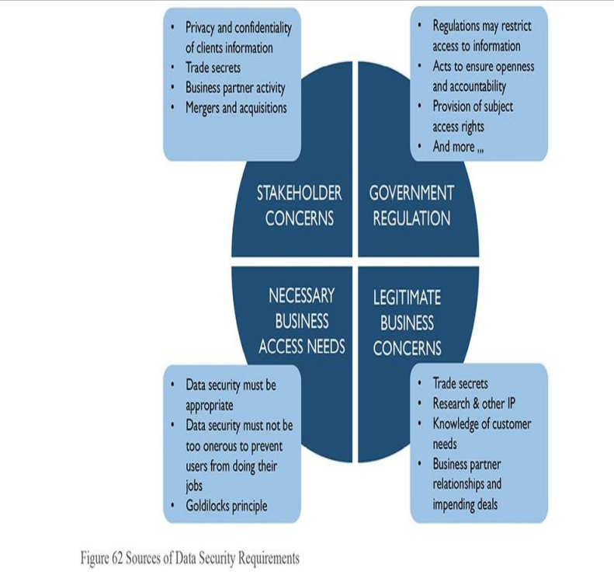

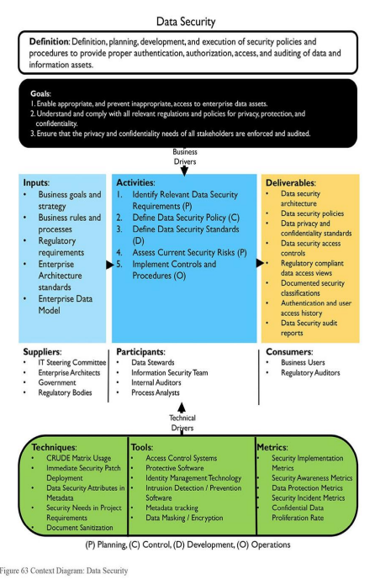

6.13 Access Method

6.14 Data Quality
Data quality includes defining, monitoring, and maintaining data integrity, and improving data quality as well as the operational processes necessary to accomplish data quality initiatives.
In accordance with the International Association for Information and Data Quality (IAIDQ), the processes the Project should consider for information quality (using a modified IAIDQ analogy to be manufacturing quality) are:
- Assess data and process quality
- Control processes that produce and alter the data
- Improve, monitor, and audit processes that produce and alter the data to meet or exceed customers' expectations and requirements
Data is valuable if and only if the data is reliable, consistent, and of high quality. For data to be relevant and useful, it is imperative that the quality of data is high. Data quality generally deteriorates over time unless the proper checks and balances are put in place to monitor the quality of data and corrective actions are taken for ongoing data quality improvement. Capabilities of tools and programs necessary to manage data quality include:
- Profiling (i.e., collecting statistics or informative summaries about the data)
- Parsing, standardizing, and cleansing
- Visualization
- Matching, linking, merging, and splitting
- Multi-domain support
- Workflow
- Scalability and performance
- Use cases to address MDM, operational/transactional data quality, information governance initiatives, data integration, data migration, and big data
The future state should include the necessary tools and processes to manage the quality of all transactional, reference, master, historical, metadata, temporary, and temporal data throughout its lifecycle. This includes performing any necessary validations of existing data, controlling the processes that produce or alter data, and providing mechanisms to maintain proper audit trails of all new or existing data.

Data Quality – TBD With the right data quality tool, you can perform data cleansing, data deduplication, data matching, and data consolidation all within one platform, code-free, using a point-and-click interface.
Implementation Guidelines
Improving the quality of data within an organization is not an easy task – even when data quality improvement efforts are launched from within a data governance program and with the support of senior management. A classic academic discussion is whether it is better to implement a Data Quality program top-down or bottom-up. Typically, a hybrid approach works best – top-down for sponsorship, consistency, and resources, but bottom-up to discover what is actually broken and to achieve incremental successes.
Improving data quality requires changes in how people think about and behave toward data. Cultural change is challenging. It requires planning, training, and reinforcement. While the specifics of cultural change will differ from organization to organization, most Data Quality program implementations need to plan for:
- Metrics on the value of data and the cost of poor-quality data: One way to raise organizational awareness of the need for Data Quality Management is through metrics that describe the value of data and the return on investment from improvements. These metrics (which differ from data quality scores) provide the basis for funding improvements and changing the behavior of both staff and management.
- Operating model for IT/Business interactions: Business people know what the important data is, and what it means. Data Custodians from IT understand where and how the data is stored, and so they are well placed to translate definitions of data quality into queries or code that identify specific records that do not comply.
- Changes in how projects are executed: Project oversight must ensure project funding includes steps related to data quality (e.g., profiling and assessment, definition of quality expectations, data issue remediation, prevention and correction, building controls and measurements). It is prudent to make sure issues are identified early and to build data quality expectations upfront in projects.
- Changes to business processes: Improving data quality depends on improving the processes by which data is produced. The Data Quality team needs to be able to assess and recommend changes to non-technical (as well as technical) processes that impact the quality of data.
- Funding for remediation and improvement projects: Some organizations do not plan for remediating data, even when they are aware of data quality issues. Data will not fix itself. The costs and benefits of remediation and improvement projects should be documented so that work on improving data can be prioritized.
- Funding for Data Quality Operations: Sustaining data quality requires ongoing operations to monitor data quality, report on findings, and continue to manage issues as they are discovered.
Data Quality and Data Governance
A Data Quality program is more effective when part of a data governance program. Often data quality issues are the reason for establishing enterprise-wide data governance. Incorporating data quality efforts into the overall governance effort enables the Data Quality program team to work with a range of stakeholders and enablers:
- Risk and security personnel who can help identify data-related organizational vulnerabilities
- Business process engineering and training staff who can help teams implement process improvements
- Business and operational data stewards, and data owners who can identify critical data, define standards and quality expectations, and prioritize remediation of data issues.
A Governance Organization can accelerate the work of a Data Quality program by:
    - Setting priorities
    - Identifying and coordinating access to those who should be involved in various data quality-related decisions and activities
    - Developing and maintaining standards for data quality
    - Reporting relevant measurements of enterprise-wide data quality
    - Providing guidance that facilitates staff involvement
    - Establishing communications mechanisms for knowledge sharing
    - Developing and applying data quality and compliance policies
    - Monitoring and reporting on performance
    - Sharing data quality inspection results to build awareness, identify opportunities for improvements, and build consensus for improvements
    - Resolving variations and conflicts; providing direction

Data Quality Policy
Data Quality efforts should be supported by and should support data governance policies. For example, governance policies can authorize periodic quality audits and mandate compliance to standards and best practices. All Data Management Knowledge Areas require some level of policy, but data quality policies are particularly important as they often touch on regulatory requirements. Each policy should include:
- Purpose, scope and applicability of the policy
- Definitions of terms
- Responsibilities of the Data Quality program
- Responsibilities of other stakeholders
- Reporting Implementation of the policy, including links to risk, preventative measures, compliance, data protection, and data security
Metrics
Much of the work of a Data Quality team will focus on measuring and reporting on quality. High-level categories of data quality metrics include:
- Return on Investment: Statements on cost of improvement efforts vs. the benefits of improved data quality
- Levels of quality: Measurements of the number and percentage of errors or requirement violations within a data set or across data sets
- Data Quality trends: Quality improvement over time (i.e., a trend) against thresholds and targets, or quality incidents per period
- Data issue management metrics: Counts of issues by dimensions of data quality Issues per business function and their statuses (resolved, outstanding, escalated) Issue by priority and severity Time to resolve issues
- Conformance to service levels: Organizational units involved and responsible staff, project interventions for data quality assessments, overall process conformance
- Data Quality plan rollout: As-is and roadmap for expansion
  - Master Data Management
  - Address Standardization
  - Email Verification

6.15 Performance Standards
7. Data Standards – MIMS data in logical, and physical data models will adapt to vocabulary standards defined for entities, attributes, and definitions developed by national standards organizations dedicated to standardizing Medicaid data to facilitate MITA’s goal for modularity and interoperability. NC MES division will adapt data standards from the following workgroups:

- CAQH - Council for Affordable Quality Healthcare: “CAQH CORE® (Committee on Operating Rules for Information Exchange) is an industry-wide collaboration committed to the development and adoption of national operating rules for electronic business transactions. Technical standards and the supporting operating rules specify the business actions required for each party to ensure a high volume of reliable electronic transactions. In 2012, CAQH CORE was named by the Secretary of the U.S. Department of Health and Human Services as the author of three phases of operating rules for HIPAA-mandated standards for electronic transactions”.

- NIEM - National Information Exchange Model version 3, for “core data” class names such as ORGANIZATION and PERSON, with ENTITY as the superclass for any business party; ACTIVITY to represent a business event; IDENTITY; LOCATION and ADDRESS; and use of “ASSOCIATION” naming for intersection of many-to-many relationships among classes.

- NMEH - National Medicaid EDI Healthcare: is a common vocabulary that enables efficient information exchange across diverse public and private organizations. NIEM can save organizations time and money by providing consistent, reusable, and repeatable data terms, definitions, and processes.

- HL7 RIM - Health Level 7 (HL7) Reference Information Model (RIM): The HL7 RIM is a static model of health and health care information as viewed within the scope of HL7 standards development activities. It is the combined consensus view of information from the perspective of the HL7 working group and the HL7 international affiliates.

- HIPAA – Health Information Portability and Accountability Act, Transaction Code sets standards create a uniform way to perform electronic data interchange (EDI) transactions for submitting, processing, and paying claims

- T-MSIS (The Transformed Medicaid Statistical Information System) - CMS has developed research-ready files, called TAF. The TAF consist of research identifiable files (RIFs) with beneficiary-level data that are available with an approved Data Use Agreement. The TAF RIFs include data from calendar years 2014, 2015, and 2016, and will be used by CMS, oversight entities and researchers to answer key questions about the Medicaid and CHIP programs. NC MES division is a current participant of this initiative.

Key Considerations of the MITA Data Management Strategy

- Common Data Architecture

– Establishes standard data-management procedures for the data models. The data architecture provides specific guidelines regarding data documentation, data-sharing development and use applicable to both structured and unstructured data, and management of metadata of all types. These guidelines ensure that the SMA defines data entities and attributes, data models, and relationships to convey the overall meaning and use of Medicaid data and information. Common data architecture improves the consistency in the development and deployment of systems, increases the
The term Common Data Architecture is used to describe acceptance of common industry standards, and best practice applied to all data models, metadata management, sharing and use of structured, semi-structured, and unstructured data. Accepting this standard will ensure that all parties responsible for system design will utilize the established standards, use pre-defined naming standardized for Medicaid entities, attributes, and metadata management during data modeling to convey the overall meaning and use of Medicaid data.

The Seven Standards and Conditions, Concept of Operations(C00), Business Process Model, MITA Maturity Model, State Self-Assessment (SS-A), MITA Maturity Models (MMM), Concept of Operations (COO), and Business Process Models (BPM) provide a foundation for common data architecture. The goals of common data architecture include: ν Defined data to support the business “To-Be” goals. ν Improved consistency in the development and deployment of systems. ν Increased the data quality and performance of systems. ν Normalization of data across applications. ν Decreased complexity of the Extract, Transform, and Load (ETL) process ν Decreased resource expenditures involved in new or redesigned system efforts. ν Identification, documentation, and limitation of the number of source data locations and access points. ν Reduced redundant data by improving communication about available classes and attributes, as well as assigning owners to promote modeling responsibility.

